**Project 3**

# **Garden Market Co-ops**

* An overview
* Screen-by-screen design layouts
* Roles by group member.
* Schedule for completion of tasks
* Screenshot of Project Management Board breakdown of tasks

# An overview

User can search for a co-op in their neighborhood. A list of co-ops will come up.

**Gardner:**

User can click on a co-op to learn more about it or choose to create a new one. If they click on an existing co-op, they can read about it or join it.

If they choose to join the co-op, they can fill out their address, what they plan to grow, how much, etc. Their name (or garden name) would show up under that co-op.

If user chooses to create a co-op, they define their role and what they grow. They are then the organizer. They can tell a bit about their group, share images, updates, etc.

**Non-Gardeners:**

Non-gardeners can use the site to find out more about the garden and garden market days and times. They can donate money to different co-ops.

They can donate supplies or materials to co-ops.

They can volunteer their time or request a garden visit or come learn about the garden from gardeners who are happy to share.

# Screen-by-screen design layouts

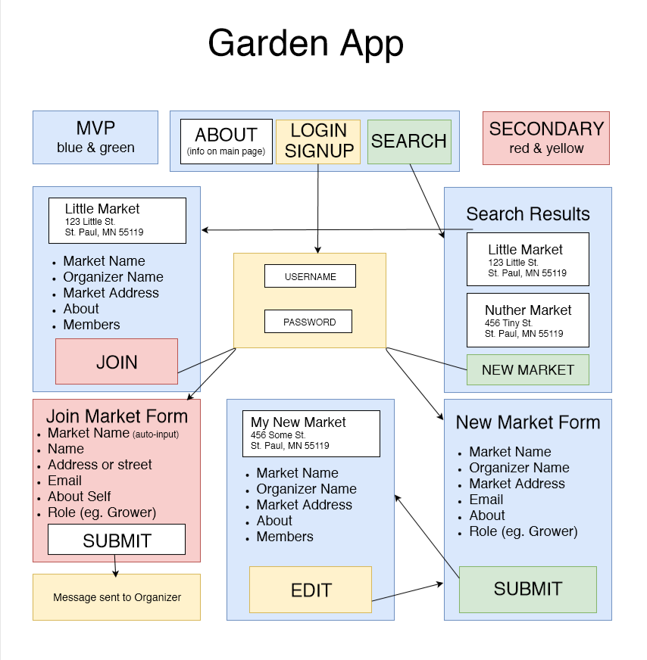

# Roles by group member

**Team Size:** 4

**Team Member’s:**

* Pranab
* Shilpa
* Brain
* Simon

**Role and Responsible:**

1. **Pranab:**

Mode - Database Setup, defining all collection required for the project, connection setting to MongoDB

1. **Simon:**

Model - Mongoose connection to project and defining ORM layer to provide common function to handle get, put, post and delete requests

1. **Brian:**

View - Architect for initial phase of project, Creating UI design layout, working on required MVP components.

1. **Shilpa:**

Controller – creating API routes to from UI to DB, creating all possible routing using get, put, post and delete request and login, Sign Up Authentication for application.

# Schedule for completion of tasks

**Tasks:**

1. Server Setup
   1. React Js Server
2. Create UI components
3. Create Utils
   1. google API
4. Create Pages
   1. home page
   2. Search result pages
   3. New market form
   4. Market info page
5. Create Models
   1. Setup Mongo
   2. Create collections
      1. Create seeds
6. Create Controllers
   1. API routing
7. Upload to GIT repository
8. Deploy to Heroku

**Screenshot of GanttPro Work breakdown:**

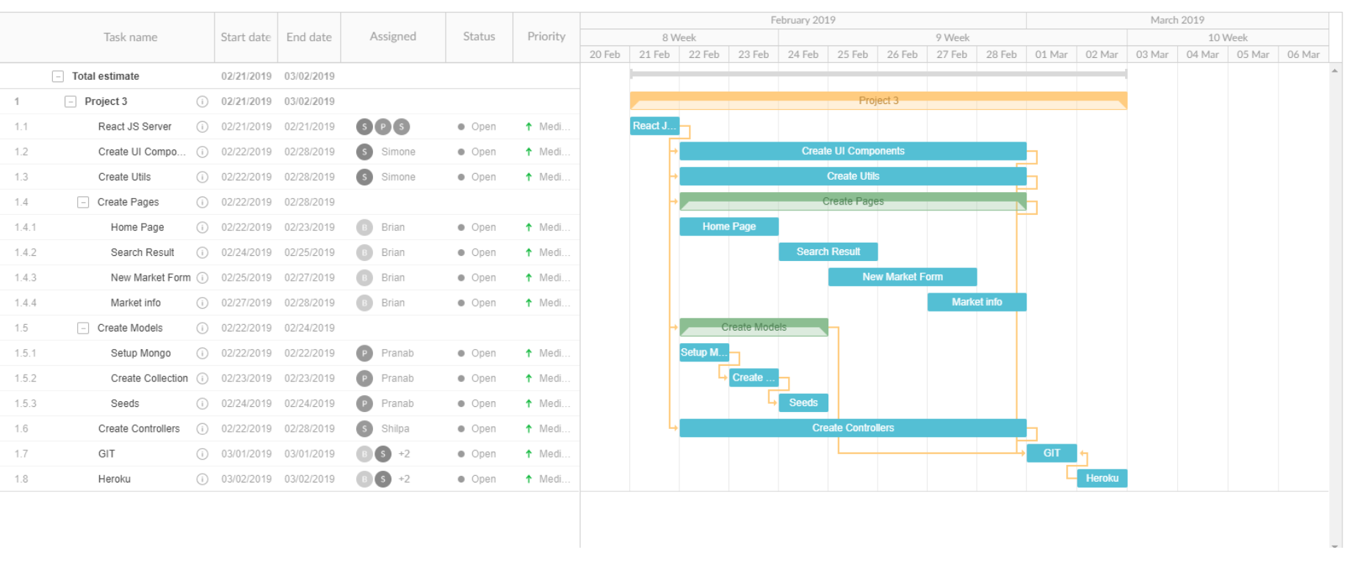

# Screenshot of PM Board tasks

